
VETERAN CARE SCHEME
Questions & Answers

Please return completed registration forms to the above address or email:equineadmin@happa.org.uk
The Veteran Care Scheme

HAPPA are looking for extraordinary people with equine experience, to come forward offering forever homes in which elderly HAPPA equines can prosper and continue to have a good quality of life. We are looking to place elderly equines into experienced forever homes with carers that are willing to invest the necessary time, energy and commitment to keep the horse or pony in the best possible condition.
- Have you got room to offer a forever home to an elderly equine?
- Have you got the commitment to ensure the horse or pony in your charge continues to have a good quality of life?
- Are you dedicated to invest valuable time and effort to consistently care for a HAPPA Veteran?
- Have you got the emotional intelligence and strength of character to work with HAPPA to ensure the elderly equines best interests are kept at heart and comply with HAPPA’s policies and protocols in correlation with our Centre.
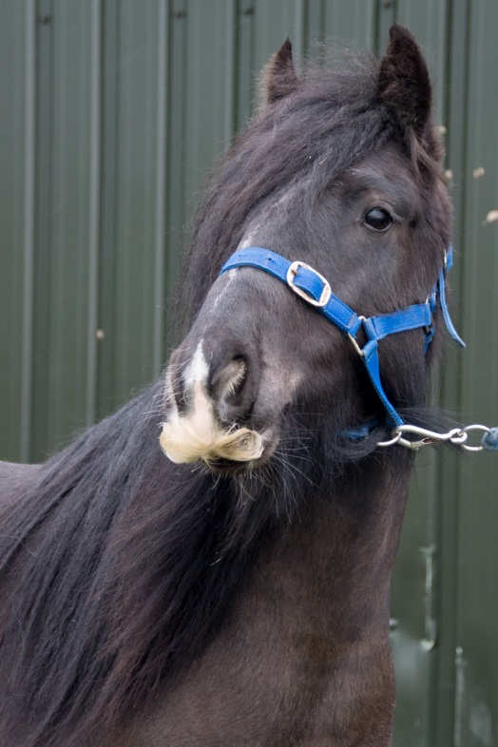
Caring for a HAPPA Veteran can be both satisfying and rewarding. You contribute to the equines welfare by facilitating a bespoke duty of care; the ultimate goal is to secure a positive future, in a permanent home. Your support and guidance will promote an elderly equines chance for a better quality of life. Being involved with an older horse or pony can prove challenging, but at the same time the benefits bring fulfilment and gratification. Elderly equines still require confident and consistent handling to ensure their welfare needs are met. Veteran Care Scheme placements will ideally continue until it is time to say goodbye.

I am interested in Caring for a HAPPA Veteran. What do I have to do?
A- First you need to register you’re interest in the Veteran Care Scheme. Complete and online loan application by visiting www.happa.org.uk (paper applications on request). When your application is received we will inform you whether you have been successful in registering on the Veteran Care Scheme. Once registered your premises will be visited by a member of our Equine Support Team to make sure you have adequate facilities to care for a HAPPA veteran.
Q- Is there any cost to registering as a HAPPA Veteran Care Scheme?
A- No. However if a suitable veteran horse or pony becomes available you will be invited along for an informal chat and a handling assessment. You will be required to make yourself a HAPPA member. Currently the fee is £20 full adult and £10 senior citizen. Children under the age of 18 are unable to register as a HAPPA Veteran Carer.
Q- Do I need to sign anything?
A- Yes. You must sign a disclaimer before starting the handling assessment; every care is taken to assess the equine prior to a member of public being invited to the centre. HAPPA accept no responsibility whatsoever for any loss, accident or injury caused as a result of handling a HAPPA Veteran horse or pony.
Q-Do I need to be experienced in handling horses or ponies?
A- Yes. HAPPA are looking for extraordinary people with relevant equine experience and knowledge to provide homes in which elderly HAPPA equines can receive the specialist care and attention needed to ensure they are in the best of health in their later years.
Q- Do I need insurance?
A- Yes. HAPPA insists that all HAPPA Veteran Carers take out Third Party Public Liability Insurance for their chosen equine. BHS Gold Membership is an affordable option. This insurance is the direct responsibility of the person signing the Veteran Care Scheme which is, therefore, without prejudice to HAPPA.
Q- Do I need to pay any fees?
A- No. HAPPA will provide funding for associated cost in relation to the health care of our veteran horse or pony: support is excluding of livery and day to day routine costs. These include
- Routine vaccinations
- Annual teeth checks
- Farrier care and trims
- Routine worming
- Any related veterinary costs (capped @ £500 colic surgery exempt) – terminal illness such as Equine Cushings Disease; HAPPA’s policy is not to medicate newly diagnosed (this must be discussed with our support team before taking a decision to medicate).
- Q- What routine Health Checks are compulsory?
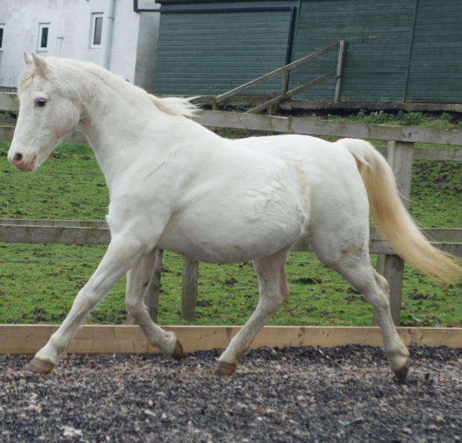
A-HAPPA insists that Veteran Carers comply with routine health screening and do all that is necessary to keep the equine in sound health including specifically ensuring that it is vaccinated against tetanus at intervals as directed by the veterinary surgeon, routine farrier care, worming and annual dental checks are also a compulsory requirement.
Q-What about Equine Passports and Care Plans?
A- Every equine leaving our rescue centre has a unique Equine Care plan & passport; some will also have a microchip. The cost of the passport is refundable (currently £25) this fee will be refunded to you when the veteran equine returns to the Rescue Centre.
Q- Do I need insurance?
A- Yes. HAPPA insists that all HAPPA Veteran Care Givers take out Third Party Public Liability Insurance for an equine on loan from the association (BHS Gold Membership) is an affordable option. This insurance is the direct responsibility of the person signing the agreement, which is, therefore, without prejudice to HAPPA.
Q- How do I get him home?
A- You may make your own travel arrangements, providing that the horse trailer/box meets with current welfare in transport regulations. Alternatively HAPPA provide a delivery service free of charge to HAPPA Veteran Carers.
Q- What support will I get?
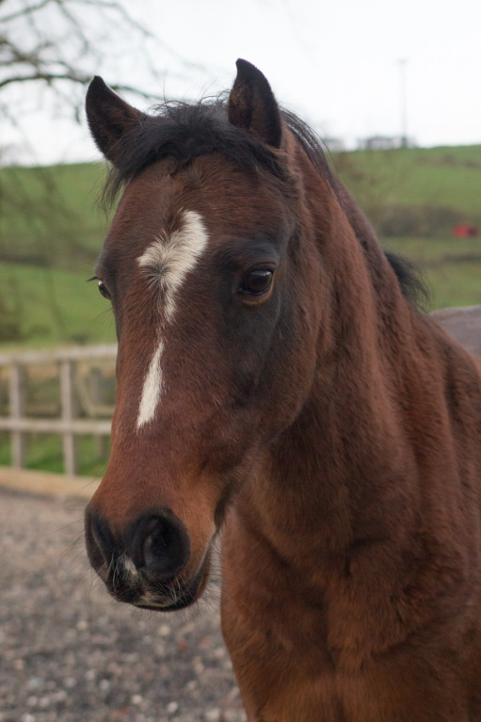
A-In the interim your Support Officer will be in touch during the 1st 6 weeks after that when your veteran horse or pony is settled into his or her new environment you will be visited routinely every 3 months by your designated HAPPA Loan Support Officer. We are committed to ensuring every elderly equine offered on the Veteran Care Scheme has a good quality of life. To ensure we honour this commitment you will be asked to contact the Equine Action Team if your elderly equine becomes unwell, we can then decide together how to proceed in line with Centre Policies.
Q- How long can I keep him?
A-We are looking for long term Veteran Carers able to responsibly monitor the health of their allocated equine to ensure their quality of life is their first priority. A veteran Carer needs the strength of conviction to be able to make a sometimes difficult decision about the allocated equines future. At HAPPA we promote quality over quantity and work hard to ensure that the equine remains at the forefront of any decision over and above the emotions of subjectivity.
Q-What happens if I want to move him to a new kept at address or I move?
A- You must inform HAPPA of any intended change of address. If your relocation means that your equine needs to be moved too, new premises or a change of livery yard will need prior inspection.

Please Think Carefully! Before registering for the HAPPA Veteran Care Scheme remember being responsible for any elderly equine can prove challenging and time consuming, please ensure you have the spare time and commitment to give an elderly equine enough care and support. HAPPA do not rehome equines without companionship, if you do not already have an equine you may be offered more than one elderly equine to care for. ‘You will be helping HAPPA to continue the rescue, rehabilitation and rehoming of the many equine in our care.’

